Lab 3: OLAP Basic Queries

# 1. Overview

This lab introduces how to use SQL statements to query a data mart. We will use the approach of “learning with examples”. That is, you will be given a range of examples of SQL queries, and you will need to read them and understand their meanings before running them with a computer.

To get started, download the data mart with the name sales_data_sqlite_db.zip provided on Canvas (an SQLite database file). This file is in zip format. Extract it and open it with SQLite.

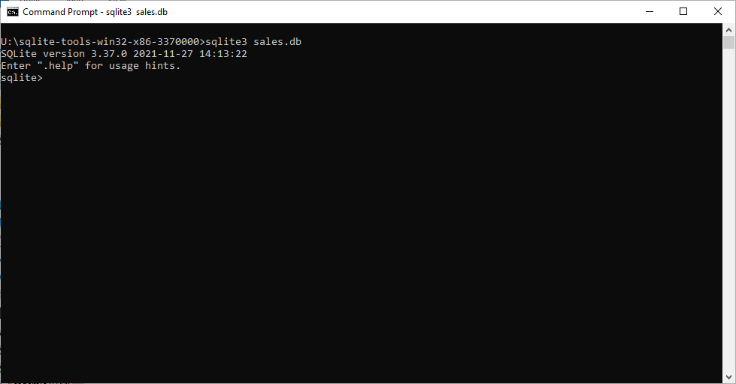

# 2. First SQL Queries

Firstly, change the mode of SQLite to table by running .mode table. Then, read the following queries to understand why they are written in such ways. Finally, execute the following queries in the SQLite Shell.

Query 3.1a: Show the total receipts of all products of the category 'Bread'.

SELECT SUM(F.receipts) as receipts

FROM Sales F, Product P

WHERE F."keyP" = P."keyP" AND P.category = 'Bread';

Query 3.1b: Show the total receipts of all products of the category 'Bread' in the year 2011.

SELECT SUM(F.receipts) as receipts

FROM Sales F, Product P, Date D

WHERE F."keyP" = P."keyP" AND F."keyP" = D."keyD"

AND P.category = 'Bread' AND D.year = '2011';

Query 3.1c: Show the total receipts of all products in Jan 2011.

SELECT SUM(F.receipts) as receipts

FROM Sales F, Product P, Date D

WHERE F."keyP" = P."keyP" AND F."keyP" = D."keyD"

AND D.month = '2011 Jan';

# 3. Using GROUP BY

Query 3.2a: Show the sales in 2011. Break down the numbers by product brand and category.

SELECT P.category, P.brand, SUM(F.receipts) as receipts, SUM(F.quantity) as quantity

FROM Sales F, Product P, Date D

WHERE F."keyP" = P."keyP" AND F."keyD" = D."keyD"

AND D.year = '2011'

GROUP BY P.category, P.brand;

Query 3.2b: Show the sales receipts and sold amount of the product category 'Bread' and 'Hot Beverages' during the period Dec 2010 to Feb 2011.

SELECT P.category, D.month, SUM(F.receipts) as receipts, SUM(F.quantity) as quantity

FROM Sales F, Product P, Date D

WHERE F."keyP" = P."keyP" AND F."keyD" = D."keyD"

AND D.month in ('2010 Dec', '2011 Jan', '2011 Feb')

AND P.category in ('Bread', 'Hot Beverages')

GROUP BY P.category, D.month;

# 4. Sorting

Query 3.3a: Show the sales receipts and quantities in 2011. Break down the numbers by product brand and category. Sort by sales receipt in descent order.

SELECT P.category, P.brand, SUM(F.receipts) as receipts, SUM(F.quantity) as quantity

FROM Sales F, Product P, Date D

WHERE F."keyP" = P."keyP" AND F."keyD" = D."keyD"

AND D.year = '2011'

GROUP BY P.category, P.brand

ORDER BY receipts DESC;

Query 3.3b: Show the sales receipts and sold amount of the product category 'Bread' and 'Hot Beverages' during the period Dec 2010 to Feb 2011. Sort by sales receipts in increasing order.

SELECT P.category, D.month, SUM(F.receipts) as receipts, SUM(F.quantity) as quantity

FROM Sales F, Product P, Date D

WHERE F."keyP" = P."keyP" AND F."keyD" = D."keyD"

AND D.month in ('2010 Dec', '2011 Jan', '2011 Feb')

AND P.category in ('Bread', 'Hot Beverages')

GROUP BY P.category, D.month

ORDER BY receipts;

Query 3.3c: What are the sales quantity and receipts of products of type ‘Soda’ in the city ‘Los Angeles’ in 2010? Order the result in total receipts (i.e., which is the best-selling ‘Soda’?)

SELECT P.product, SUM(F.receipts) as receipts, SUM(F.quantity) as quantity

FROM Sales F, Product P, Store S, Date D

WHERE F."keyP" = P."keyP" AND F."keyS" = S."keyS" AND F."keyD" = D."keyD"

AND D.year = '2010'

AND P.type = 'Soda'

AND S.city = 'Los Angeles'

GROUP BY P.product

ORDER BY receipts DESC;